What is ALM (Application Lifecycle management)
Software plays a key role in the digitalization of manufacturing process in manufacturing industries.
ALM is used to control the lifecycle of software in manufacturing industries. PTC Integrity Lifecycle manager is an ALM tool by PTC.
ALM plays key role in manufacturing industries like Automotive, Medical and Elevators.

ALM has three important modules.
- Requirement management
- Testing and validation
- Source configuration.

Requirement management is used to manage and digitalize the requirements.
Testing is done is each phase of manufacturing to narrow down the possibility of error.
In source requirement repository is used to store data and to do collaborative work. This will result in reuse of resources.
ALM follows v- model because when the requirement comes the same time corresponding test cases are made. It will also help to easily split one particular stage to sub stages.
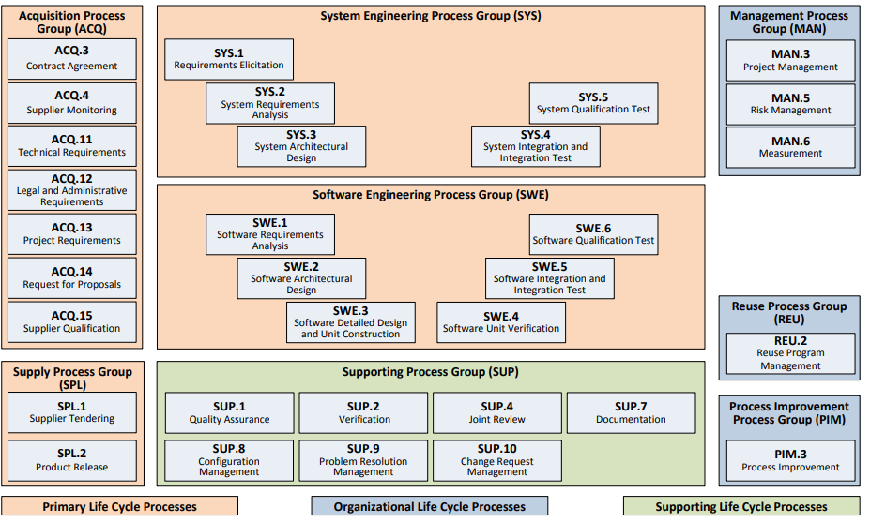

Architecture of Integrity
Integrity

DB
Flex Net

Standard user 1
Sc3
Sc2
Admin user

Flex net is used to check the license of user each time when the app gets connected to the server.
Integrity is a thick client.
Project
Project is a container of metadata.
Project

Container Backing Item
Container is used by admin. It is used for defining ACL(Access control lists)
Backing Item is used by standard user. It holds data and all the information about the project like created date, working states, states of activities. ..etc.

Integrity Data model
Segment(Document)
Node (Content)
Shared Item
None (items)
Segments are documents where users will add simple attributes and contents(nodes). So Segment are used in situations where ,
we have type relationship to be established.
we have to reuse the template( eg: test cases for any vehicle part, it will be same for the particular part).
Incase of export of data based on relation.
Nodes are also type but, do not have any existence without being embedded to any segment as an attribute. So when the admin makes a document first node has to be made and then this can attach to the document as an attribute.
Shared Item.

Note:
Documents (also called Segments) are the container objects for Content (also called Nodes, which are paired with Shared Items), which are connected by relationship fields (Contains \ Contained By). Content items have a related Shared Item which is related by the References \ Referenced By field. The Node uses Field Value Attribute (FVA) fields to point at data that exists on the Shared Item. The purpose of the Shared Item is to store the data for re-use within the same document or across multiple documents.
Content can be either Meaningful or Non-Meaningful. This is controlled by the Shared Category field on the shared item (exposed to the user by the Category field on the node). An example of a meaningful piece of content would be a Technical Requirement. An example of a non-meaningful piece of content would be a Comment or Header.
Reference Modes
Reference Modes control how content is shared and reused between documents. There are three Reference Modes:
- Author: The content belongs to the current document and has its own shared item. When you create new content in a document, its reference mode is Author. You may also copy content using Paste Content Special > Copy to create a new node in another document that has the same content but with its own shared item.
- Share: Share reference mode is used when content is copied from one document to another and both items point to the same shared item. The copied content cannot be modified directly – it is simply a window to the original content (which will have a Reference Mode of Author). When the original content item is modified, the update is reflected in the copied content. For example, if you have a set of standard practices as a Header included in a document and want to use that Header again in subsequent documents, you copy it to another document as Share – this way when the standard practices change, you are only updating one item (the original) and the updates are automatically propagated to the copied content. When you are sharing content between documents with Share reference mode, a special built in relationship field is used. This is the Shares / Shared By relationship field.
- Reuse: Reuse is appropriate when you want a copy of the current content but plan to evolve it separately from the original content while maintaining the ability to trace back to its origin. When you copy a piece of content and paste it into a document with a reference mode of Reuse, it will still point to the same shared item until a Significant Edit is made. Once a Significant Edit is made, a new Shared Item is created. Content that is created using Reuse Reference Mode always points back to the content it originated from (designated by Branched From) – this is how Reuse differs from Author:

Significant Edit Fields
Significant Edit Fields are defined on Segments, Nodes and Shared items. They are configured under the Document Model section when editing a Type in the Integrity Administration Client. Significant Edit Fields are important for the following reasons:
- When a Significant Edit Field changes, the Input Revision Date field is updated.
- Only edits to Significant Edit Fields cause the Shared Item to branch when using a Reference Mode of Reuse.
- Only Significant Edits result in Content marked as Suspect.
  - ​Suspect content is content that has significantly changed and may no longer satisfy its related test results

Items do not have any attributes which link to other types. These are used if there is no relationship needs to be established between types.

Creating user
Log on to admin client and new user can be created under
Mksdomain->users->RC->create
After creating user log in permission has to be given to the user
Mks Domain is the directory server for managing user credentials.
Ghost user : user whose account has been deleted from directory server.

Log in and switching users in standard client
Query-> manage query-> new-> credentials.
If query is not visible customize the viewset and give query visibility.

ViewSet
In standard client every activity depends on permission for all users.
Viewset can be created or imported and these viewset can be customized and given visibility to show more menus.

Creating project
First give create project, admin permission to the user
Then go to w & d -> create project
Give name and add groups in the permissions tab.
Now project has to be released for this backing item has to be created.
RC project -> Create backing item-> now project / library has to be selected.
Creating Document
Log in to the standard client document -> create-> select document type
->now select where it has to be created (project / library)
To make one document as a template create the document inside the template and keep the classification of that particular library as a template.
Now we can go to document -> create from template -> select the template.
Relationships
Relationships help to properly track between requirement, function, design and testing of the functionality before a particular mile stone is reached. There are mainly three types of relationship fields in Integrity.
Standard relationship fields
QBR
IBPL
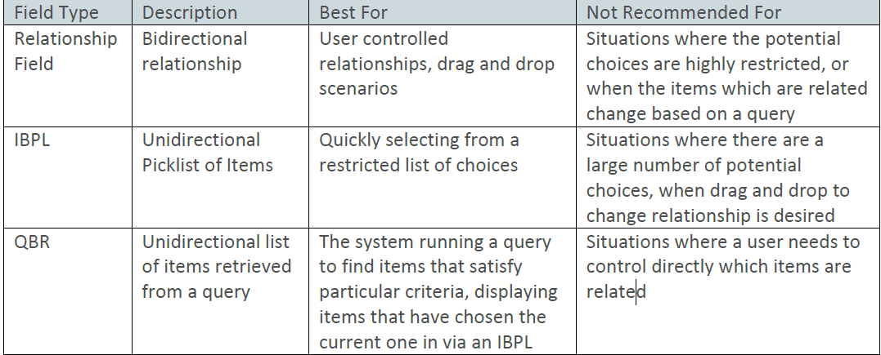

Traceability
It’s a special relationship used to relate contents or documents with other documents.

For Eg one document can contain many contents. Here documents holds contains relationship with content and content holds contained by relationship.
There are many types
One to one- Here Trace is created between two contents of one document. Here the Trace Status will be related
One to many- Here content of one document is traced to another document. The destination will have upstream relationship (Trace Status) with the source and the source will have downstream relationship (Trace Status) with the destination.
Many to one- More than one contents from documents / document can be traced to a single document.
Many to many – contents from multiple documents can be traced to multiple documents
To create Trace Do ALT + Drag and drop one content to another.
Notes:
1)To create a Trace Relationship

Select MKS Solution and Edit Type

Create a trace property with

a. Name: MKS.RQ.trace.<typename>
b. Value: <Relationship field/trace to be created>:<typename for other end of trace>

2) In the Admin Client, go to Workflows and Documents>Fields>Create Field (or edit field if you have field created, but have not named it as a Trace field) .
- In the "Suspect" column, marking this as true means core product will handle setting suspect.
- If you mark "false" for suspect, this means you are either not setting suspect, or you have a trigger that will do the work for setting suspect.

Standalone Architecture
We can have cluster set up of multiple servers and clients which will be licensed by one flex net server.

Server 1
C1 , C2 . C3
Set up 1
Flex Net
Flex net
Server 2
C1 , C2 . C3

Set up 2

Set up n
Server n
C1 , C2 . C3

Default port number of flex net : 8090
Property files in folder structure
Integrity-> server-> config-> properties
- Is.property-> tells about db, license path, etc
Here,
mksis.apiSession.defaultUser=
mksis.apiSession.defaultPassword=
These two entries are used for creating session during customization.
- Im. property
Line 7,8,8,10 used for setting different servers like test, prod
Server which is locked is called locked server and which has locked is called staging server.
Eg,:- development server is staging
Test server is staging / locked
Production server is locked
- Integrity_11.0\Server\data\public_html
to change or customizing images use
If we want to use any custom images use the image url as
Hostname:port/name.extention
Eg: for the image D:\ptc\Integrity_11.0\Server\data\public_html\MKS_ALM_2009\bar.png
Use the below link
http://bltsp00016:7001/MKS_ALM_2009/bar.png
Federated Server Architecture (FSA)
FSA provides managers and development teams in a distributed development organization to work collaboratively and successfully. FSA provides real time access to data to the local system from the host server. The local system gets data from remote host server through proxy set up. The synchronization process will be done in background and the user wont be affected by this process.
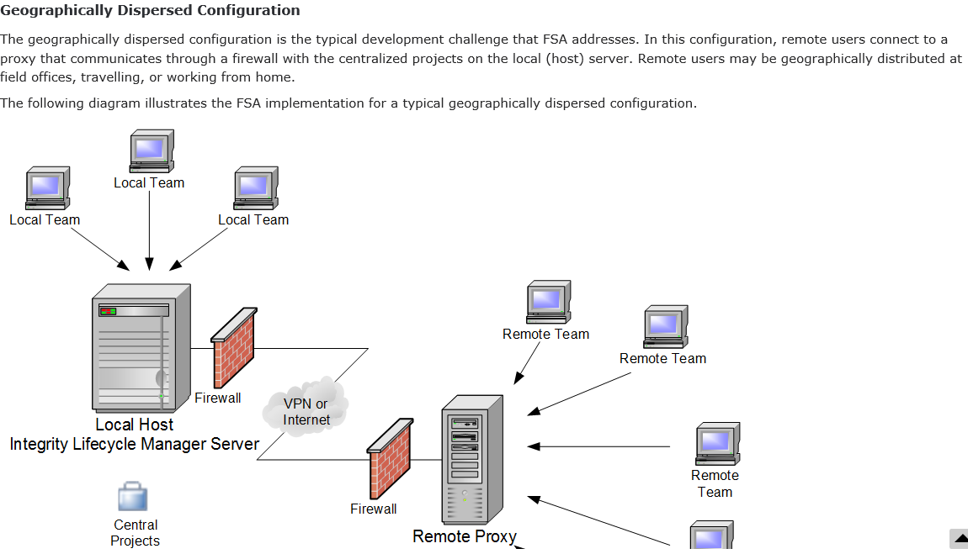
_________________________________________________________________________
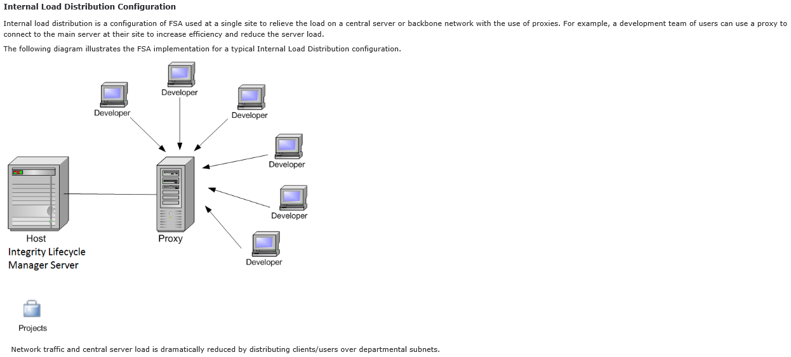

Creating custom Fields
Fields act as attributes for types. According to the requirement custom fields can be created.
To create field go to work flow and documents -> fields -> RC-> Create new field->
Next the data type has to be selected ,
Available data type options are,
Attachment, Date, FVA, Floating point, Group, Incoming External Reference, Integer, IBPL, Logical(True, false), Long Text, Phase, Pick (Normal Picker), QBR, Range, Relationship, SI Project, Short Text, Source Link, user
Here Range is an OOTB Computed field for integer. We can have labels as range based on the value of some other integer field. It’s a read only field.
For eg . we have an integer field age and we are creating a Range field called status. While creating status we can have conditions like
Minor = age<18
Major = age>=18

While configuring values if computed fields are required it has to be selected and proper equation has to be added. Later it is possible to change the equation of computed field but, it is not possible to change the field as a non computing field.
Relevance is also important as if No Relevance is checked this field wont be displayed in the UI for the particular type where the field is used. It will be hidden.
Editability is other important configuration. If Never Editable is checked user cant enter value for this field.
Attributes tab can be used to hide/ show tabs like workflow, history, images.
Complex Fields
IBPL
Its used to populate fields of another item as a picker.
Active items will be displayed in the picklist, inactive items wont.
IBPL values can be restricted by filters.
FVA (Field value Item)
FVA fields serve as a window from one item to a field on a related item.
This is only applicable only on related items. Based on the forward or backward Relation the field in one item can be shown in the other item as a read only field.
They can be editable or read only. For Multivalued Relation FVA is not possible.
QBR (Query Backed Relationships)
Use QBR fields to display a large number of related items in a read-only
relationships field, based on a query.

You can restrict QBR fields by state or other rules.

Creating Custom Item
To create item go to work flow and documents -> item -> RC-> Create new item->
Now give name, display name
Three settings are important here :
Visible Fields :- here all the required fields has to be selected from available fields and permission has to be given for each field
Document model :- Here Role has to be selected like Segment / Shared Item / Node / None
Work flow :- Here the data flow has to be designed based on the available states.
For each state if required mandatory fields have to be selected.
For each transitions permissions have to be defined.

Creating Presentation Layout for Item
To have a custom presentation go to presentation and if we are not pleased with the existing presentations we can create new presentation and add to the view, edit/submit, print UI.
In the design window we can arrange fields into rows and columns , control text size, control styles, arrange fields into groups , customize images , etc features are available.
Creating Group
Groups consists of one or more users. For creating group first it has to be created in mks domain then the same group has to be created in workflow and documents -> group-> create new
After creating group we can add users to group.
Dynamic Groups
Unlike static groups dynamic groups allow to add members to the group separately for each project.

Workflow
Used to route the data flow from one state to another. Three components of workflow are Transitions, State and Permissions.
Permissions have to be defined for each transitions (which group has the responsibility to access it).
It’s a good practice to add admin group along with the required group.
Parallel task is not possible in integrity workflow.

Field Constraints in Items
Constraints are used to limit the number of available values if the field is a multi-valued ( picker ) or to make the field mandatory if the field is single valued.
This can be set under edit type -> constraints.
The four constraints are,
Basic : Its used to filter values in a picklist

IBPL: its used to filter the values of IBPL picklist based on the specific condition of some other field.

Field Relationship: its used to filter one field value based on other. For example based on the country states have to be displayed

Rule: Its used to filter one field value based on one or more field values. Its not a good practice to have rule on IBPL field.

States
States are the available transitions in a work flow as the type gets maturity.
Custom states can be defined under
work flow and documents -> states-> create state.
There are also phases for work flow. Multiple states can be combined to form a phase according to the user requirement.

Relationship
Relationships are used to establish the link between multiple type or fields in a single type.
To create Relationship field select field type as Relationship. Now in Type select the source type and in allowed type select the target type. The target types can be multiple. Select multivalued if multiple values are allowed. Now select browsing style as query, for this query for the type has to be generated first.
Now Forward relationship will be established between source and the destination and Backward relationship will be established between destination and source.
Library
Libraries are used to store data which are not specific to any project and also to store Templates.
When backing item for a project is created in the admin client it is has to be chosen how it should be backed in the standard client. Here we have to select either Project or Library. Libraries are of two types,
Single and Template.
Single Library is used to store generic data and Template Library is used to store Templates.
Query
Queries are helpful to search types in standard client. Its good practice to create query for all the types we create. To create query go to queries under work flow and documents then create .
Here we can give filters according to the requirement.
Test Management
Test management manages the process of testing a system or application that is being prepared for a release.
There different phases for test management.
- First we have to create a test document. The testing will be conducted against this document.
- Now Test object has to be created. Here the document has to be tested should be attached. The Test Object should be in a state of in development or Assigned state to go for In Testing.
- After that Test plan has to created. Here the Test Object has to be attached.
- Finally the Test Session has to created. Here there are two important attachments. Firstly the Test Plan has to attached and after that we can select respective test documents embedded with it.

Here everything for Test document is done.
Now the created Test Session has to be tested. For this select the Test Session and click on the Test tab. Now select Result editor for Testing purpose.
Put the state as IN Testing and mark each test item as pass / fail
Now the state can be marked as completed.

Re hosting
Its used to replicate the contents from one server installation to another server installation.
First we have to note down the parameters of source and destination Servers.

Eg : DBhostname : same as host name
DB Port :1433
DB name : INTEGRITYDB
DB user : ALMDBADMIN
DB admin : sa

Step 1
Turn off Integrity server from windows services for source and destination.
Step2
Go to source system
Sql server -> Data base -> Integrity db -> Rc-> Task-> Back up
Then choose
Database : IntegrityDB
Back_up : full
Backup component : DB
Backup to : D:\\Integrity source Rehsoting\\IntegrityDB-Full Database Backup.bak
Media options : overwrite all existing backup sets.
Back up options: IntegrityDB-Full Database Backup
Step 3
Now copy Integrity config and data folder from source to the re hosting folder.
Step 4
If target is not blank do the back up of target Integrity db and server folders on the same way as above.
Step 5
Copy the Integrity source re hosting folder from source to destination.
Step 6
Open destination db
Database->RC->Deice-> browse->give the path of source db back up file
Destination : IntegrityDB
Option: overwrite the existing Data base
OK
Step 7
Now replace the contents of data folder in destination with contents of the source data folder except tls and license directories.
Then in the Config folder replace encryption.properties of destination with that of source.
Step 8
If we want to restore the destination after re hosting, do the following steps.
- Stop integrity server
- Restore DB with the backup of destination
- Replace the whole data and config folder of destination with the destination backup
- Now start the Integrity server

Overriding field properties for particular type
The field properties like visibility(Relevance), Editability etc can be over ridden of for particular type using override field property of type. There by the field re usability can be maintained.
Rules on Relationship field
Rules are used in Relationship field for some specific tasks.
Available rules are
Maintain Relationship count : This is used to keep a count of number of related items

Workflow restricted by related item : This rule is used to restrict the parent item to reach a particular state until the all the child items reach a particular field.
Post and maintain linked items
Summation of relationship tree : Its used to calculate the sum of a particular field in the child items as a sum to display in the parent item.
Staging server configuration
Below steps explains how to do a staging / lock server configuration

Locked Server
Staging server

Step 1
Install and Configure the Staging Server(s).
Step 2

For each Staging Pair, create/configure a user in the Locked server and the credentials of this user will be maintained in the staging server. The password of this user should never expire.
Step 3
The staging server should be identical to that of locked server. So do the re hosting by keeping staging server as destination and locked server as source.
Step 4
Configure the Staging Server as an Admin Staging Server. For this do the following steps.
- im.properties
The connection to the Production server for the Staging Pair needs to be configured in this file
- mksis.im.prodServer=<Hostname or Alias to Production server>
- mksis.im.prodPort=<Port configured for the Integrity Server on Production>
- mksis.im.prodUser=<User created/configured in Step 2 above>
- mksis.im.prodPassword=<Password for the User created/configured in Step 2 above>
- is.properties
Tell the server to start up as a Staging server instead of a standalone server
- mksis.adminStagingServer=true
Optionally, you can provide a name that will display in the title bar of any connections to the Staging server in the Admin GUI
- mksis.adminStagingServerDisplayName=<Text to display>
If not configured, the Server will display "Staging Server" as default text

Step 5
Shut down all servers
Step 6
Start up Production Server
Step 7
Start up Staging Server(s) and Verify Admin Lock.

Once the lock has been established the locked sever will be restricted to do any changes. The changes done under the work flow and documents in the staging server can be migrated to the locked server with the help of data migration.

Dashboard
It’s a user defined view containing charts, reports, queries, Labels, images, and links. when designing the dashboard its possible to choose the components and place of the components.
To create Dashboard go to Dashboard-> Create Admin Dashboard
Here project filter can be defined for the dashboard.
Project Filter
Open : all projects will be available, also we can give default projects.
Fixed : If this is set at run time the project filter cant be modified.
Restricted: Allows only these projects to be selected at run time.
None: Project filter will not come at run time.
Chart
It’s a graphical representation of the summary of the item data.
There are four types of charts :- Trend chart, distribution chart, item field chart, item fields trend chart.
Distribution chart : Here one or more values of two fields will be shown in a graph in x and y axis based on a query.
Item field chart :Here we can have numeric fields and combination of numeric fields on Y axis and Item identifier on X axis.
Trend chart : it’s also based on queries. We can have multiple values of a field based on particular start date and end date.
Item fields trend chart : Its combination of both trend chart and field chart.
Basic steps in creating a custom document
1. Modify the Shared Category field.
2. Create the Shared Item Type including: adding Visible Fields(Shared Text, Shared Attachments), adding Significant EditFields (Shared Text, Shared Attachments), Workflow, BasicConstraint on the Shared Category, and Field Override for the Shared Category.
3. Create the Node Item Type: adding Visible Fields, adding Significant Edit Fields (Category, Text, and Text Attachments), Copy Fields, Workflow, Basic Constraint on the Category field,
4. Create the Segment Item Type including: creating an MKS.RQ.Domain property, adding Visible Fields, adding Significant Edit Fields (Shared Text, Shared Attachments), Copy Fields, Workflow, Basic Constraint on the Shared Category, and Field Override for the Shared Category.
5. Create additional Field Relationship Constraints for the Node Type.
6. Set editability of Significant Edit Fields.
7. Update the References field to include new allowed types.
8. Update the Documented By field.
9. Create Admin Queries.
10. Create Relationship Fields.
11. Add Relationship Fields to Item Types.
12. Edit fields to allow relationship types.
13. Enable drag and drop relationships.
14. Create trace properties. Note: To enable traces between Functional Elements, the MKS.RQ.selftrace MKS Solution Type property needs to be updated to include the Functional Interface To and Functional Interface From traces on the Functional Element Type.
15. Create item type presentation templates.Once you have ensured students have all of these steps, have them create the two domains in Integrity, referring to the exercise guide only as necessary..

Proposal / Quotation management (Enquiries management)
OEM => original Equipment Manufacturer
User story
Sales man

Delivery head

Project Manager

Sales man gets requirement from client. Project manager estimates and gives the quotation. If the client agrees the project will win and pm will create project in Integrity
Adding new Category in content
- Add category name to shared category field as meaningful / nonmeaningful
- Edit the content and add the newly added category as allowed value on shared category constraint ( field relationship)
- Edit the Shared category type and add the newly added category as allowed value on shared category constraint (Basic)

